# Unit 5 Assignment

# Amon-ra

# Herzing University

BU 630-7A Project and Operations Management

**Introduction**:

Technology is constantly changing and rapidly advancing. With these advances comes efficiency, convenience, and improved effectiveness. One of those advances is the cloud. The use of the cloud has seen rapid growth. In 2012 public cloud market revenue was $26.4 billion U.S. dollars in the United States alone. The figure has grown to almost 10 times that number to $228.9 billion U.S. dollars. Again, that is in the United States alone.

**Figure 1. Public cloud market revenue worldwide from 2012 to 2026 (in billion U.S. dollars)**

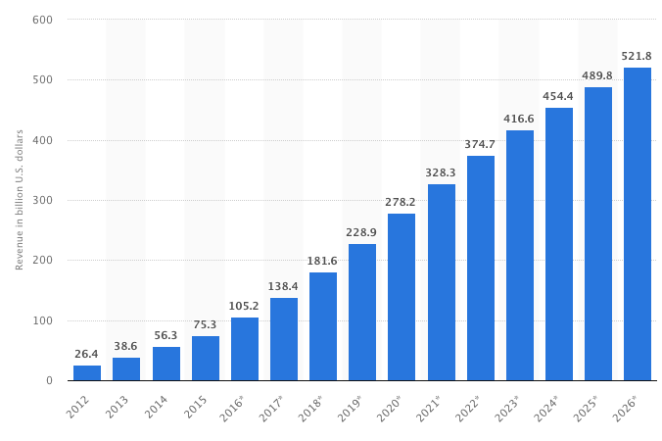

Note Reprinted from Cloud Computing Growth Means Big Business, No Author. Retrieved from Cloud Computing Growth Means Big Business. (2018, February 8). Retrieved from https://www.27machines.com/cloud-computing-growth-means-big-business/ Copyright 2020 — 27 Machines

Worldwide, cloud technology usage has grown from $182.4 billion U.S. dollars in 2018 to $214.3 billion U.S. dollars. Growth is projected to surpassed $331.2 billion U.S. dollars by 2022. This presents a growth opportunity for our company, InterTech. The company can position itself to capture a share of the cloud market and grow that market share along with the expanding use of the cloud. From the provided stats, we can see that cloud technology will either grow with or without us. It is beneficial for InterTech to harness the opportunity and grow with the technology.

**Table 1. Worldwide Public Cloud Service Revenue Forecast (Billions of U.S. Dollars)**

|  |  |  |  |  |  |
| --- | --- | --- | --- | --- | --- |
|  | **2018** | **2019** | **2020** | **2021** | **2022** |
| Cloud Business Process Services (BPaaS) | 45.8 | 49.3 | 53.1 | 57.0 | 61.1 |
| Cloud Application Infrastructure Services (PaaS) | 15.6 | 19.0 | 23.0 | 27.5 | 31.8 |
| Cloud Application Services (SaaS) | 80.0 | 94.8 | 110.5 | 126.7 | 143.7 |
| Cloud Management and Security Services | 10.5 | 12.2 | 14.1 | 16.0 | 17.9 |
| Cloud System Infrastructure Services (IaaS) | 30.5 | 38.9 | 49.1 | 61.9 | 76.6 |
| **Total Market** | **182.4** | **214.3** | **249.8** | **289.1** | **331.2** |

BPaaS = business process as a service; IaaS = infrastructure as a service; PaaS = platform as a service; SaaS = software as a service

Note Reprinted from Gartner Forecasts Worldwide Public Cloud Revenue to Grow 17.5 Percent in 2019, No Author. Retrieved from https://www.gartner.com/en/newsroom/press-releases/2019-04-02-gartner-forecasts-worldwide-public-cloud-revenue-to-g Copyright 2020 Gartner, Inc. and/or its affiliates.

The first initiative to align the company with industry trends regarding the cloud is to offer support for SD-WAN. SD-WAN stands for Software Defined Wide-Area Network. It uses “software to control the connectivity, management and services between data centers and remote branches or cloud instances. Like its bigger technology brother, software-defined networking, SD-WAN decouples the control plane from the data plane.” (Cooney, 2019) InterTech has partnered with network industry giant Cisco to advocate the adoption and provide support for Cisco’s SD-WAN technology.

**Advantages of SD-WAN**

* Agility – SD-WAN can combine the bandwidth of multiple WAN connections to create a larger pipeline to accommodate network traffic.
* Cost – Uses regular internet connections, which are cheaper than MPLS (Multiple Packet Label Switching)
* Security – Encrypts and segments WAN traffic.
* Performance – SD-WAN decouples the control plane from the router to allow processing power to be utilized for other functions. This along with combing multiple WAN connections improves overall WAN performance.
* Management – Network automation associated with day-to-day management activities such as detecting outages for traffic rerouting and handling traffic based on priority.

**Strategy**:

The first phase of the SD-WAN initiative calls for our sales team becoming acquainted with the product and soliciting it to our current and potential customers. Presently, our current customers are using Cisco ASR (Aggregation Services Router) and ISR (Integrated Services Router) routers. The sales team will serve on the front lines of the offensive to convince our customers migrate from the older technology and adopt the newer SD-WAN solution. The sales team will work a list of customers sorted in chronological order based on date in that the account became active.

Figure 2. Cisco SD-WAN vEdge Routers

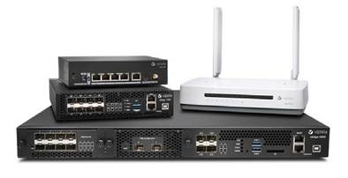

Note Reprinted from Cisco SD-WAN vEdge Routers Data Sheet, No Author. Retrieved from Solutions - Cisco SD-WAN vEdge Routers Data Sheet. (2019, November 6). Retrieved from https://www.cisco.com/c/en/us/solutions/collateral/enterprise-networks/sd-wan/nb-07-vedge-routers-data-sheet-cte-en.html Copyright by Cisco

The sales team approach will consist of scheduling a sales event with groups of customers and complete with presentations, whereby the sales team will introduce customers to the world of SD-WAN and the cloud. The sales team will point out the challenges faced by the de-facto standard of businesses connecting to the WAN and present the resolution to bridging the gap between business and the shortcomings of the correctly used router hardware. The benefits of our SD-WAN solution will be highlighted and the team will seek commitments for a follow-up in order to work toward a solid agreement to migrate.

The second phase of our company’s SD-WAN initiative involves members of our engineering team to be trained by Cisco engineers regarding the installation, configuration and maintenance of their Viptela SD-WAN router. Cisco will send an engineering team to InterTech locations where InterTech engineering teams will undergo a week long training regarding the Viptela SD-WAN router. Our engineering team will be responsible for the following:

* Designing a migration solution for customers
* Install the Viptela SDWAN router
* Configure the Viptela SDWAN router
* Provide support for Viptela SDWAN router
* Conduct Viptela SDWAN router maintenance
* Decommission the outgoing router during migration

In order to convince our customers of the joys of Cisco SD-WAN, it is necessary that we lead the way by migrating to SD-WAN ourselves, so that we can speak from experience. This is will entitled us assist our customers in walking down a road that we ourselves have traveled. It quite difficult to convince people of something that one hasn’t experienced for themselves. The InterTech network team has prepared a test environment to present to successes to the management team. At the conclusion of the test presentation, I will seek the approval to implement the SD-WAN solution at one of our branch offices for a go-live demonstration. Subsequently, remaining locations will follow.

**Risks**

1. Fears of the cloud
2. Customers that feel their present hardware is adequate.
3. Customers that the budget to fund the new technology
4. Migration complications

**Risk** **Mitigation**

1. Ensure that customers understand the cloud and address any myths and fears regarding the cloud
2. Conduct research using past trouble tickets and interviews customers to identify challenges in order to discover circumstances where SD-WAN can be offered as a solution.
3. Identify budget friendly ways to make the migration affordable for companies that need it.
4. Be prepared with rollback plans, monitor successful migrations for a full 24 hours for complications. Have teams on standby to provide immediate support for migrated sites.

References

Cloud Computing Growth Means Big Business. (2018, February 8). Retrieved from https://www.27machines.com/cloud-computing-growth-means-big-business/

Cooney, M. (2019, October 9). SD-WAN - What it means for enterprise networking, security, cloud computing. Retrieved from https://www.networkworld.com/article/3031279/sd-wan-what-it-is-and-why-you-ll-use-it-one-day.html

Edwards, J., Smith, G., Froehlich, A., Wilkinson, M., Nangare, S., Connolly, J., & Munshi, A. (2019, March 27). SD-WANs Benefits Extend Beyond Cost Savings. Retrieved from https://www.networkcomputing.com/networking/sd-wans-benefits-extend-beyond-cost-savings

## Gartner Forecasts Worldwide Public Cloud Revenue to Grow 17.5 Percent in 2019. (n.d.). Retrieved February 9, 2020, from https://www.gartner.com/en/newsroom/press-releases/2019-04-02-gartner-forecasts-worldwide-public-cloud-revenue-to-g

## How SD-WAN Can Future-Proof Your Operations. (2019, April 15). Retrieved from https://biztechmagazine.com/resources/white-paper/how-sd-wan-can-future-proof-your-operations

## Solutions - Cisco SD-WAN vEdge Routers Data Sheet. (2019, November 6). Retrieved from https://www.cisco.com/c/en/us/solutions/collateral/enterprise-networks/sd-wan/nb-07-vedge-routers-data-sheet-cte-en.html

## Staff, B. T. (2019, April 15). 6 Advantages to a Software-Defined WAN Implementation. Retrieved from https://biztechmagazine.com/article/2016/12/6-advantages-software-defined-wan-implementation

## Viptela. (2019, May 24). Retrieved from https://www.cisco.com/c/en/us/about/corporate-strategy-office/acquisitions/viptela.html#~tab-overview